**Brazilian E-Commerce Dive Deep using SQL**

This dataset has information about the customer and its location. Use it to identify unique customers in the orders dataset and to find the orders delivery location.

Please refer to the data schema:

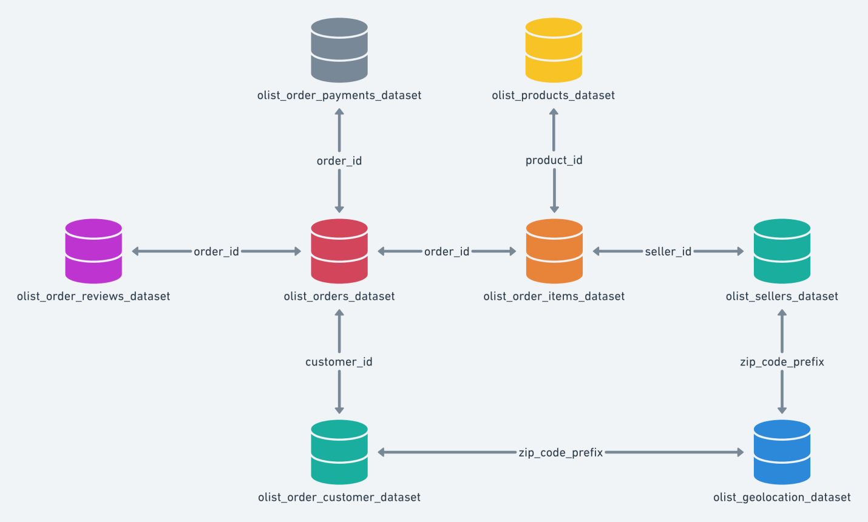

First create relationships between tables and then write SQL Queries:

1. Average order payment, Count of orders for the customers.
2. Count purchased in Jan-2018 with 5 Review score.
3. Customer purchase trend Year-on-Year.
4. Average of days between order date and delivery date.
5. Top 5 Cities with highest revenue from 2016 to 2018.
6. In year 2018, flag each seller as (below target – within target – above target) based on no of sold items and revenue.
7. Extra request on the project last Saturday is:
8. SP to get Top N Products sold per each seller, the SP will take N , OrderStartDate, OrderEndDate. please try on it and let's discuss on our next session